Part 1: Account Planning

Wegmans Food Markets Inc, is an American supermarket chain that has 109 stores across the Northeastern, Mid-Atlantic, and Southern regions of the country. It was founded in 1916 in Rochester, NY by John and Walter Wegman. Their revenue is currently 11.2 billion dollars, and they have 52,000 employees as of 2022. Their CEO as of 2017 is Colleen Wegman. Their mission, as stated on their website, is “helping people live healthier, better lives through exceptional food”. Wegman’s is heavily involved with community giving and service, diversity and inclusion, sustainability, and nutrition and healthy eating which is reflected in their products (Wegmans Food Markets).

In terms of Wegmans products and services, the selection is vast. The grocery stores offer 50 – 70,000 food, drink, houseware, health, and beauty products. Less traditional of a grocery store, Wegmans stores include The Buzz Coffee Shop, Pizza Shop, A Market Café, Old-fashioned Sub Shop, a Pharmacy, a Bakery, and Floral Shop. With these added features, Wegman’s offers in store or take out dining (which includes entrees, appetizers, side dishes, and soups), made to order sushi, hot and cold subs/wraps, party trays, cookies, coffee, tea, breakfast sandwiches, thin-crust pizza, calzones, chicken wings, breads, rolls, bagels, muffins, pies, cakes, and pastries. The store also offers “Wegman’s Meals 2 Go” which allows customers to make an account, place an online order and have their food prepared for delivery, carryout, or curbside pickup. Wegmans Meals 2 Go also includes catering services too. Lastly, Wegmans offers customers a chance to become a Shoppers Club member. The benefits of this free membership include digital coupons, ability to create a shopping list, access to meal recipes, product recall updates, personalized recommendations based on what you buy most, and ability to order prescription refills, free home delivery and prescription status thru the Pharmacy (Wegmans Food Markets).

As of 2019, Wegman’s target market and audience is mainly older generations for age and women for gender. More specifically, 20% of Wegmans target audience are 45-54 years of age, 23% are ages 55-64, and 68% of the stores target audience are women (Storebrands.com) There is not much recent research regarding Wegman’s current market share. However, according to a 2005 article in The Morning Call, Wegmans market share was 12.7% and ranked number 3 among the area’s grocery stores (Marshall, 2005)

In terms of social media followings, Wegman’s has 130, 000 followers on Instagram, 202.9 thousand followers on Twitter, 493, 301 followers on Facebook, and 8,712 followers on Tik Tok. According to Craft.co, Wegman’s major direct competitors include the grocery stores Brookshire, Price Chopper, Whole Foods Market, and Safeway (Craft.co).

S.W.O.T. ANALYSIS

Strengths | Weakness | Opportunities | Threats
- Offers an array of products and services that go above the traditional grocery store (i.e. Floral shop, Sub Shop, Pizza Shop, Café, Coffee Shop, Pharmacy, Meals2Go (catering), etc.  - Heavily involved with community giving, sustainability, diversity, and inclusion  - Ranked #3 on Fortune’s “100 Best Companies to Work For”  - Consistently low prices | - Stores are not nationwide, they are consolidated to the North East, Mid-Atlantic, and South  - Not much brand awareness | - Can engage 18–25-year-olds in that this the first time for many in this age demographic to be living on their own and grocery shopping for themselves  - Open more stores in the Mid-west, West, and South-west regions of the country  - Offer student and family discounts on certain products | - Pricing competition with stores like Walmart  - Inflation raising prices which can deter many from large grocery hauls

The goal of my campaign for Wegmans is to become the primary grocery store brand among 18-25 year old’s in the Northeastern, Mid-Atlantic, and Southern regions of America. The first objective of this campaign is to establish Wegmans Food Markets as the primary grocery store amongst 18–25-year old’s, including a 30% increase in website traffic and a 15% in-store traffic increase within 6 months. The second objective of this campaign is to build brand loyalty among 18 to 25-year-old customers with 50% of them signing up to become a Shopper’s Club Member.

To specify the target audience, they are men and women ages 18-25, they make around 25k a year and above, they are primarily people who have at least a high school diploma, are working toward a bachelor’s degree, and/or already have a bachelor’s degree. They are in the cities that Wegmans has stores in, in the Northeast, Mid-Atlantic, and Southern regions of the United States. They are mainly apart of the working class and middle-class social classes. My rationale for this being that currently, Wegman’s has never explored this age group as their target audience. As of now they are mainly focusing on women and more on the older generations. By targeting 18–25-year-olds, the store will be able to expand its customer base and can cater to a portion of people who are on their own for their first time in life, buying groceries for themselves and learning to incorporate meals that sustain them while also budgeted their money. Wegman’s extremely reasonable prices and convenience of pre-cooked meals and assortment of instore restaurants and cafes can provide places of social gathering, studying, dining, among traditional grocery shopping for Gen Z.

The product/service statement will read as follows: Wegmans Food Markets Inc. is a convenient, reasonably priced grocery store that goes above and beyond to create an incredible experience for the customer. In store, customers will find a Market Café, Pharmacy, Sub Shop, Pizza Shop, Bakery, Floral Shop and Coffee Shop. The inviting atmosphere can be a space to do affordable grocery shopping as our products are 13% cheaper than competitors (Taste of Home), as well as a space for social gatherings, study sessions, and/or to enjoy a meal, snack or coffee. The Shopper’s Club membership offered at Wegmans is a customer loyalty program that allows guests to receive digital coupons as well as the ability to build savings for future purchases the more you swipe the card.

Part 2: Media Planning

In terms of media planning, researching Gen Z’s traditional and digital media habits and consumption is the most helpful starting point. Beginning with traditional media, flyers and transit display advertisements will be created and circulated in and around college campuses and business (where young adults gather) that are located close to a Wegmans store. By placing these physical ads in places where 18-25 year old’s gather (student centers, transit stops, and business such as restaurants that Gen Z frequent in said towns/cities) this age group will be reached more.

The digital media that will be used will include social media, with a focus on TikTok advertisements and Instagram reels. This is because TikTok and Instagram are enormously popular social media platforms among Gen Z. TikTok has 41.4 million monthly Gen Z users and Instagram has 37.3 million monthly Gen Z users (Hall, 2022). A Wegman’s ad on TikTok and an Instagram reel should hopefully generate brand recognition of the grocery store among the age group and increase the stores TikTok and Instagram followers thus contributing to increased website traffic. Because digital media is more popular among Gen Z than traditional media is, the former will receive more of the budget.

To the left, the pie chart represents that budget allocation for our media campaign. Traditional media will receive 28% of the budget which translates into $280,000 spent on transit shelter display advertisements and print flyers. Digital media will receive the bulk of the budget at 72%. This translates to $720,000 spent on TikTok and Instagram advertisement.

Over the course of 6 months, Marketing Key Performance Indicators (KPI) will be monitored. Marketing KPI’s “attempt to get a better understanding of how effective marketing and promotional campaigns have been” (Twin, 2022). Thus, marketing KPI’s are the perfect version to use in this case, in that they are focused on website traffic and social media traffic. The hope is that over a 6-month period, Wegmans will see more website and social media traffic which will increase in person traffic, Shopper’s Club memberships, and overall sales amongst 18-25 year old’s.

For the 6-month calendar flowchart, our campaign will run from July to January. We will launch the Tik-Tok and Instagram ads in July and run them continuously till January. Summer break provides a laxer workload from school and work, thus allowing Gen Z to have more time to spend on their phones scrolling thru social media. We will not begin the physical flyers and transit shelter advertisements until September as that is the month that many in the age group will return to their college towns, visiting their student centers, and utilizing public transport. Those ads will run from September to January.

6 MONTH FLOW CHART

Part 3: Creative – Advertising Execution

Print Flyers & Transit Shelter Display Advertisement


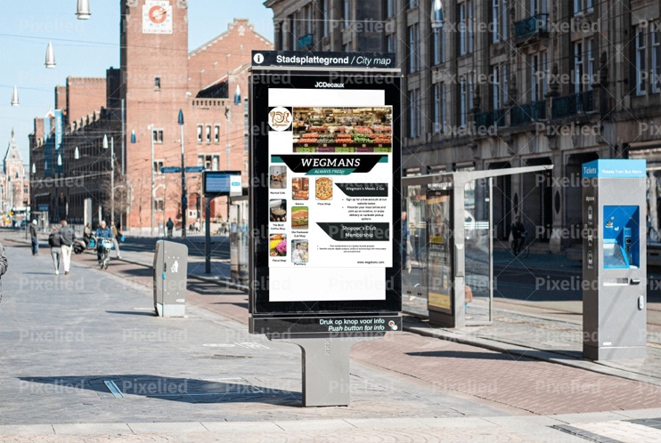
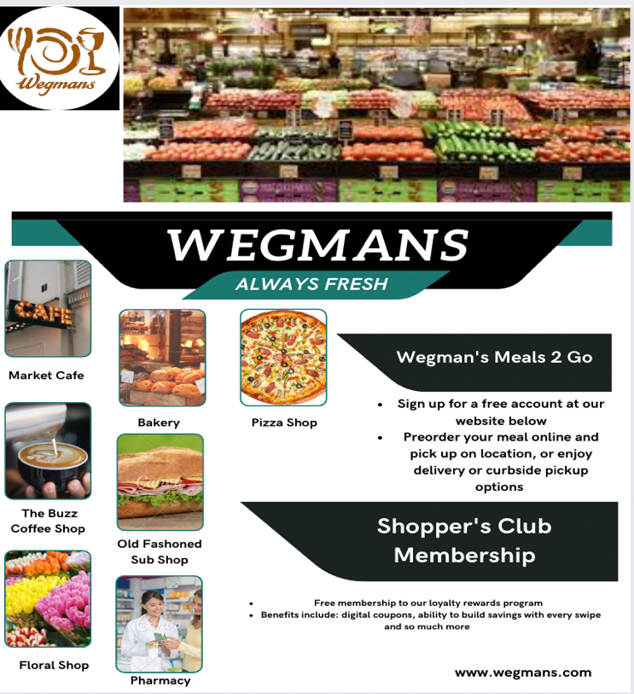
To the left is an example of what the print flyer will look like. It gives a brief look into what Wegmans has to offer beyond the traditional grocery store such as the café, pizza shop, coffee shop, floral shop, pharmacy, and sub shop. The flyer also highlights two special services of Wegmans; the Wegmans Meals 2 Go and the Shopper’s Club Membership. There is a brief description of each feature to allow the audience to get a clearer picture. The website is listed at the bottom right so that that the consumers can access it for more information. This flyer will be circulated in student centers and in businesses that young adults frequent. 18–25-year old’s engaging with this media will be able to see the variety and convenience of Wegmans. The hope is that these print ads, in conjunction with digital media ads in consistent use for a 6-month time will reach as much of Gen Z as possible. Thus, increasing traffic to the store. Once at the stores, Gen Z will take advantage of the Meals 2 Go feature and the Shopper’s Club Membership. The incorporation of the QR code on both the flyer and transit ad will make it extremely easy for Gen Z to pull out their phone, scan the code, and be taken immediately to the website to learn more information about the grocery store. The print flyer and transit advertisement are examples of Out of Home advertising (OOH) in that they are advertisements outside of the consumer’s house. By incorporating OOH advertising, Wegmans will be reaching more of Gen Z than just focusing solely on digital media.

TikTok Advertisement/ Instagram Reel

Below is the link to the TikTok advertisement/Instagram reel. The advertisement is just shy of 1 minute long. It incorporates aspects of soft selling by invoking emotion surrounding food and gathering spaces. Warm colors and inviting music add to this concept. The ad takes viewers thru mostly everything that Wegmans has to offer: their traditional grocery store layout, their café, coffee shop, bakery and sub shop and ends with mentioning the Meals 2 Go feature and Shopper’s Club membership. There is a call to action on the last slide of the ad, which tells viewers to swipe up and by doing so they will be directed to the Wegmans website to learn more information. As mentioned above, an enormous amount of Gen Z is on TikTok and Instagram. By releasing this ad/reel, Wegmans will be reaching more of Gen Z this way.

https://www.canva.com/design/DAFSj3PtsP0/QjF9lzBrWNyoAeRqiUT7ZQ/watch?utm_content=DAFSj3PtsP0&utm_campaign=designshare&utm_medium=link&utm_source=publishsharelink

References:

Danziger, P. N. (2018, March 16). Why Wegmans Food Markets gets the love of customers. Forbes. Retrieved November 21, 2022, from https://www.forbes.com/sites/pamdanziger/2018/03/03/why-wegmans-food-markets-gets-the-love-of-customers/?sh=629dbabe4ce5
Genevieve Marshall Of The Morning Call. (2021, October 5). Wegmans: Large market share with 3 stores ** regional chain shows slow growth, adding a few stores a year. ** company rank 15. The Morning Call. Retrieved November 21, 2022, from https://www.mcall.com/news/mc-xpm-2005-03-06-3586324-story.html
Hall, S. (2022, May 18). Gen Z Technology Habits and media consumption by the numbers. Basis Technologies. Retrieved November 21, 2022, from https://basis.net/blog/gen-z-technology-habits-and-media-consumption-by-the-numbers#:~:text=Streaming%20Video%20and%20Audio%20Media,at%20least%20once%20per%20day.
Project, T. M. I. (2022, November 15). Fatigue, traditionalism, and engagement: The News Habits and attitudes of the Gen Z and millennial generations. American Press Institute. Retrieved November 21, 2022, from https://www.americanpressinstitute.org/publications/reports/survey-research/fatigue-traditionalism-and-engagement-the-news-habits-and-attitudes-of-the-gen-z-and-millennial-generations/single-page/#:~:text=the%20study%20findings%3A-,Millennials%20and%20Gen%20Z%20use%20traditional%20news%20outlets%2C%20not%20just,Fully%2045%25%20do%20so%20daily.
Tarlton, A. (2022, July 25). 7 perks only Wegmans Shoppers know about. Taste of Home. Retrieved November 21, 2022, from https://www.tasteofhome.com/collection/wegmans-perks/
Twin, A. (2022, October 8). Key performance indicator (KPI): Meaning, types, examples. Investopedia. Retrieved November 21, 2022, from https://www.investopedia.com/terms/k/kpi.asp
Wegmans Food Markets Company profile - office locations ... - craft. (n.d.). Retrieved November 21, 2022, from https://craft.co/wegmans
Wegmans Food Markets: Grocery & Meal Delivery or curbside. Wegmans. (2022, November 18). Retrieved November 21, 2022, from https://www.wegmans.com/
Whole Foods, Wegmans pursue same age groups. Store Brands. (2021, December 9). Retrieved November 21, 2022, from https://storebrands.com/whole-foods-wegmans-pursue-same-age-groups#:~:text=%2Dbased%20Wegmans%20is%20mostly%20targeting,Whole%20Foods%20(61%20percent).

